Amendments To My Final Piece
Before | After
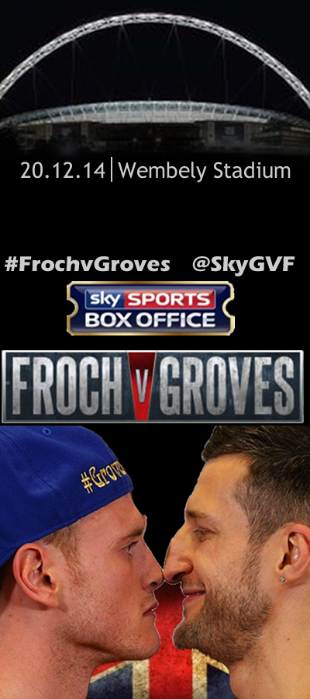
This is my design before the amendments were made. | The targets I have been given are that should crop and trim the canvas. The other improvement I have been given is to align the ‘Box Office’ and ‘Froch And Groves’ banner. Therefore, I have cropped my canvas and moved the “Froch vs Groves Banner” down a few inches to align it, which makes it looks neat, professional and perfect.
Before | After
This is my design before the amendments were made. | I have changed the font and the orientation of the writing to make it look more eye catching as my assessor said it looked boring

