Design | Explanation
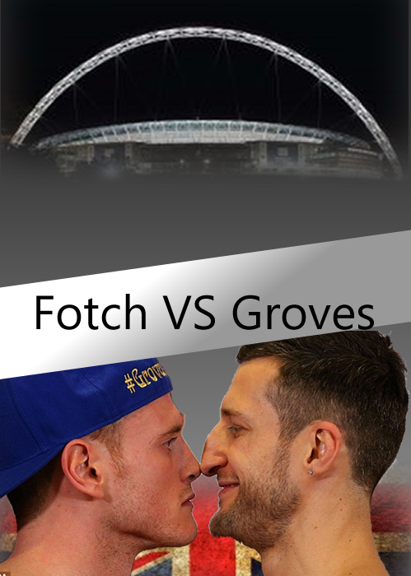 | This was my starting design. The things I was trying to achieve was showing the venue and the boxers fighting, this is because, without even reading this you can figure out what who where and when the fight is happening. I am not going to be taking this design as my best as there are Some negatives to this poster like the way the lettering is not sloping up as like the banner it is on with doesn’t give it a good effect plus it is spelt wrong. Another negative is the gradient on the background from grey to black, this is because the background needs to be one colour otherwise it will distract the viewer’s eyes to it, and this is not the most important part of the poster so it needs to be discrete but work with the rest of this advert. However, I am going to take a few things into the next design that I like. These are the faded Wembley and the faded Union Jack to represent where is and who the two people are from, this is key for the poster because it visual and less writing on the billboard. The highlight of this design is the fading of the Union Jack and Wembley Stadium, This seems to make the poster flow.
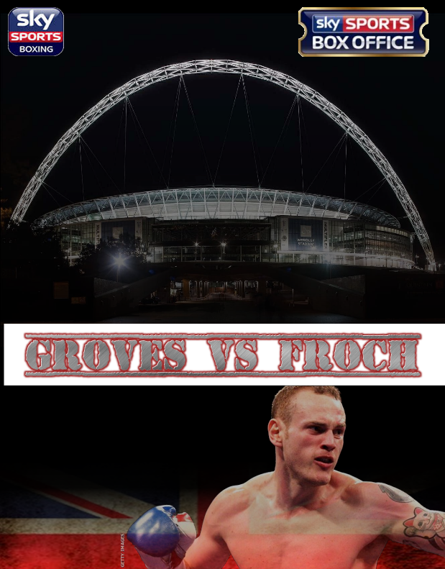 | In my second design I have brought forward the Wembley and Union Jack fade as this works well with the black background I have selected. The new things I have added are the sky sports logos the show what channel is on so the viewer can watch it and promote the company. Another thing is the black background which looks better than the gradient one in the first design, I have chosen the colour back because it is a neutral colour and it works really well with the faded Wembley. Also the title of the match which looks more professional than the first one and much eye-catching. I have put George Groves at the bottom of the advert to represent one of the fighters involved, though maybe I should have put a picture of Froch to balance this billboard. However this looks more professional than the first one so it works. Although I will not be using this as my final design however I can use a few things to put in my next design such as; The Wembley and Union Jack – again – as this is my favourite part because it shows the venue and who the fight is between without any words. Another thing I can use in the other design is the sky sports logo as it shows where to watch it and promotion of the company.
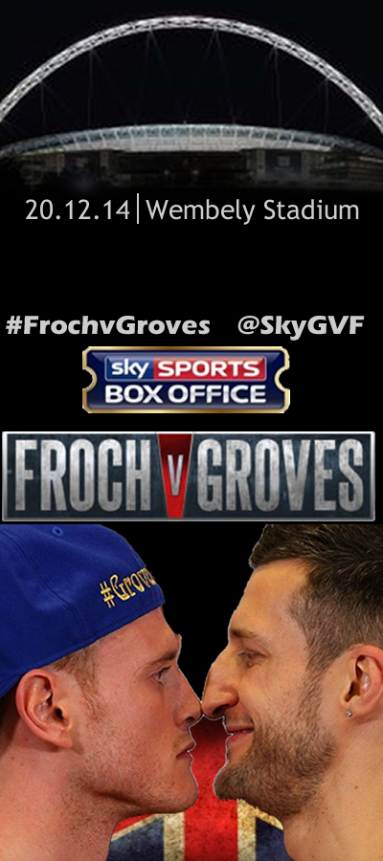 | This is my last design and I have chosen this one to be my final design as this looks the most professional and eye catching of all three. I have used the two fighters from my first design to show who is fighting and they’re rivalry, this is important because it shows such a rivalry like there’s and the importance of the match. The Wembley at the top shows that this where the fight is at the fading looks really effective and blends in with the background making it flow. The dates and information are in white to stand out and contrast the black of the background which makes it eye-catching. I have also added the hash tag and the link to twitter so they get more information instantly. The new logo of Froch and Groves gives it a professional look about it and works well with the colour scheme so it fits in. I have chosen this one because I have changes things from every other design to improve it and finally made this one acceptable and worthy of becoming a poster on bus stops and etc.

