How do static and dynamic web pages work?
Definitions-

- Static- lacking in movement, action, or change, especially in an undesirable or uninteresting way.

- Dynamic- characterized by constant change, activity, or progress

So what is a static web page?

- Created in HTML and has an .HTM or .HTML file extension

- Always looks the same when we open it/view it in browser
- E.g. this one I have created-

So what is a dynamic web page?

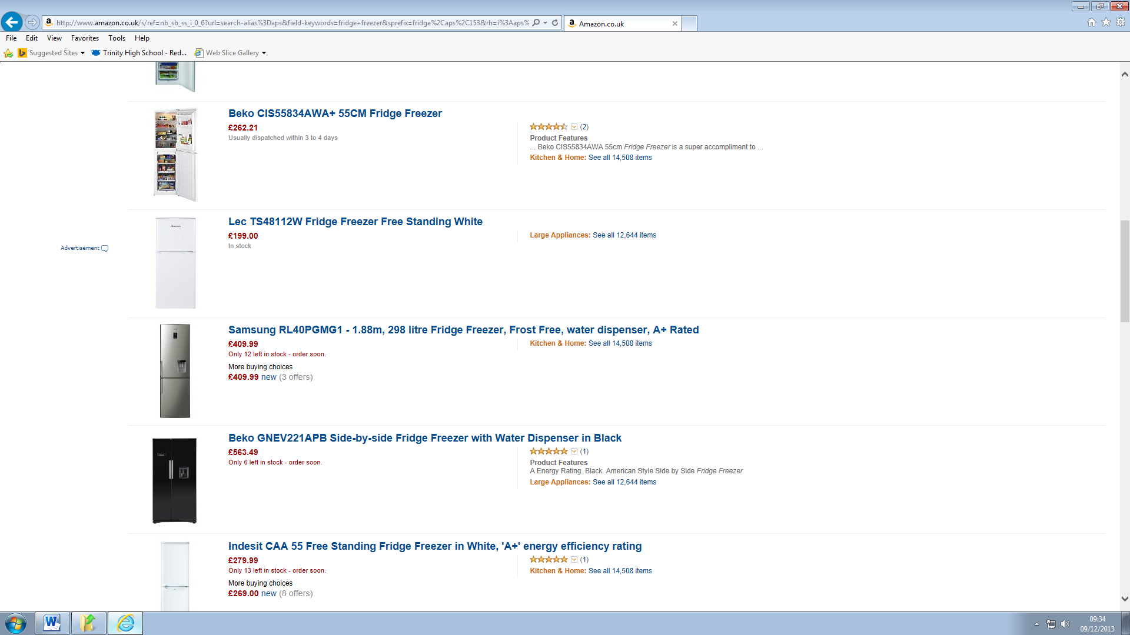

Things that stay the same | Things that change
Position of each product | Name of the product
Logo / search bar / advert position | Picture of product
Title for each product in blue | Description of the product
Picture for each product in red | The actual prise of the product

Facts
- Created using a server side technology such as PHP or ASP
- Creates the page dynamically depending on what the user has asked for e.g. a product search or specific product display
- Page is created on demand at the server, not saved as a file

