Name: Jack Crook

Billboard Advert: Carl Froch vs George Groves
Original Graphic Asset | Source (URL) | Edited Asset | Description of how asset was edited (tools used and why)
 | http://www.bbc.co.uk/sport/0/boxing/17633585 |  | Magic wand tool to get rid of the background
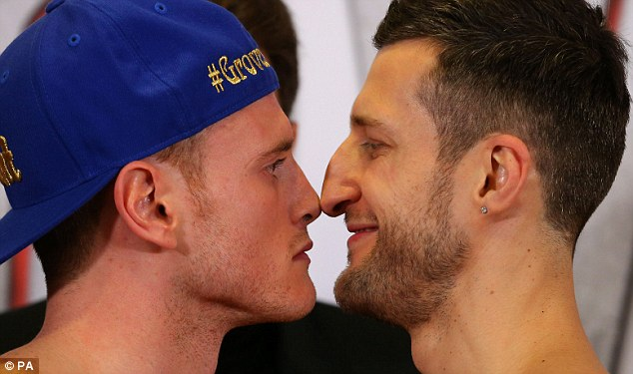 | http://www.dailymail.co.uk/sport/boxing/article-2511746/Carl-Froch-George-Groves-come-blows-weigh-in.html | 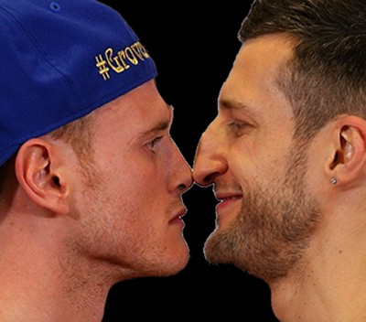 | Got rid of original back ground and replaced it with a black one. I did this with the magic wand tool and changing the canvas size
 | http://sportsvibe.co.uk/industry-news/boxing/froch-v-groves-live-on-sky-sports-box-office-28128/ |  | Replaced the background with back by changing the canvas size
 | http://fblog.futurebrand.com/2014/03/ |  | Faded it into the background by using the rectangle tool and changing the gradient to black and white the give this effect
 | www1.skysports.com |  | Replaced the background with black
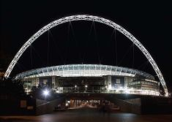 | londonslant.com | 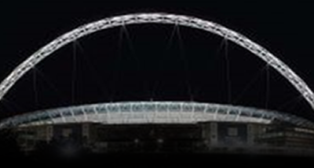 | Faded it into the background by using the rectangle tool and changing the gradient to black and white the give this effect
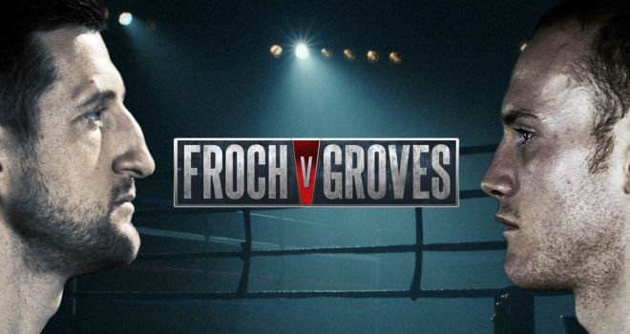 | www1.skysports.com | 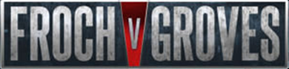 | Cropped the image so just this banner was shown and pressed ‘enter’ to save this effect

